**Introduction to Graphs**

Graph is a non linear data structure, it contains a set of points known as nodes (or vertices) and set of linkes known as edges (or Arcs) which connets the vertices. A graph is defined as follows...

**Graph is a collection of vertices and arcs which connects vertices in the graph**

**Graph is a collection of nodes and edges which connects nodes in the graph**

Generally, a graph **G** is represented as **G = ( V , E )**, where **V is set of vertices** and **E is set of edges**.

**Example**

The following is a graph with 5 vertices and 7 edges.  
This graph G can be defined as G = ( V , E )  
Where V = {A,B,C,D,E} and E = {(A,B),(A,C)(A,D),(B,D),(C,D),(B,E),(E,D)}.

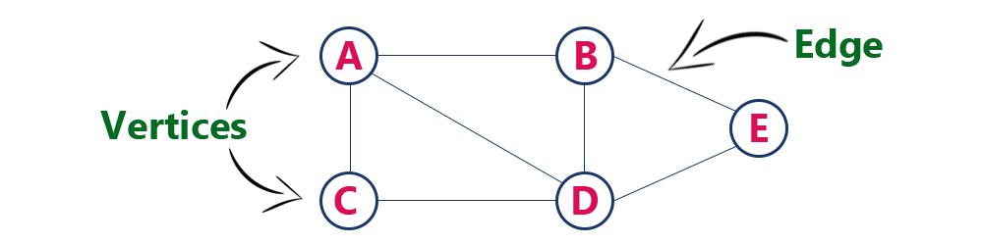

**Graph Terminology**

We use the following terms in graph data structure...

**Vertex**

A individual data element of a graph is called as Vertex. **Vertex** is also known as **node**. In above example graph, A, B, C, D & E are known as vertices.

**Edge**

An edge is a connecting link between two vertices. **Edge** is also known as **Arc**. An edge is represented as (startingVertex, endingVertex). For example, in above graph, the link between vertices A and B is represented as (A,B). In above example graph, there are 7 edges (i.e., (A,B), (A,C), (A,D), (B,D), (B,E), (C,D), (D,E)).  
  
Edges are three types.

1. **Undirected Edge -**An undirected egde is a bidirectional edge. If there is a undirected edge between vertices A and B then edge (A , B) is equal to edge (B , A).
2. **Directed Edge -**A directed egde is a unidirectional edge. If there is a directed edge between vertices A and B then edge (A , B) is not equal to edge (B , A).
3. **Weighted Edge -**A weighted egde is an edge with cost on it.

**Undirected Graph**

A graph with only undirected edges is said to be undirected graph.

**Directed Graph**

A graph with only directed edges is said to be directed graph.

**Mixed Graph**

A graph with undirected and directed edges is said to be mixed graph.

**End vertices or Endpoints**

The two vertices joined by an edge are called the end vertices (or endpoints) of the edge.

**Origin**

If an edge is directed, its first endpoint is said to be origin of it.

**Destination**

If an edge is directed, its first endpoint is said to be origin of it and the other endpoint is said to be the destination of the edge.

**Adjacent**

If there is an edge between vertices A and B then both A and B are said to be adjacent. In other words, Two vertices A and B are said to be adjacent if there is an edge whose end vertices are A and B.

**Incident**

An edge is said to be incident on a vertex if the vertex is one of the endpoints of that edge.

**Outgoing Edge**

A directed edge is said to be outgoing edge on its orign vertex.

**Incoming Edge**

A directed edge is said to be incoming edge on its destination vertex.

**Degree**

Total number of edges connected to a vertex is said to be degree of that vertex.

**Indegree**

Total number of incoming edges connected to a vertex is said to be indegree of that vertex.

**Outdegree**

Total number of outgoing edges connected to a vertex is said to be outdegree of that vertex.

**Parallel edges or Multiple edges**

If there are two undirected edges to have the same end vertices, and for two directed edges to have the same origin and the same destination. Such edges are called parallel edges or multiple edges.

**Self-loop**

An edge (undirected or directed) is a self-loop if its two endpoints coincide.

**Simple Graph**

A graph is said to be simple if there are no parallel and self-loop edges.

**Path**

A path is a sequence of alternating vertices and edges that starts at a vertex and ends at a vertex such that each edge is incident to its predecessor and successor vertex.